|  |  |  |  |  |
| --- | --- | --- | --- | --- |
| **National University of Computer and Emerging Sciences, Lahore Campus** | | | | |
| C:\Users\saif\AppData\Local\Microsoft\Windows\Temporary Internet Files\Content.Word\final design.jpg | **Course:** | **Information Retrieval** | **Course Code:** | **CS317** |
| **Program:** | **BS(Computer Science)** | **Semester:** | **Fall 2019** |
| **Duration:** | **25 Minutes** | **Total Marks:** | **10** |
| **Paper Date:** | **5-Nov-19** | **Weight** | **4%** |
| **Section:** | **A** | **Page(s):** | **2** |
| **Exam:** | **Quiz 3 solution** | **Roll No:** |  |

**Question 1:**

Given a collection of 3500 documents with 5000 unique words, draw the architecture of neural network for WordToVec training. Suppose the number of dimension of word vector is 300. Clearly write size of input layer, hidden layers and output layer. [5 Marks]

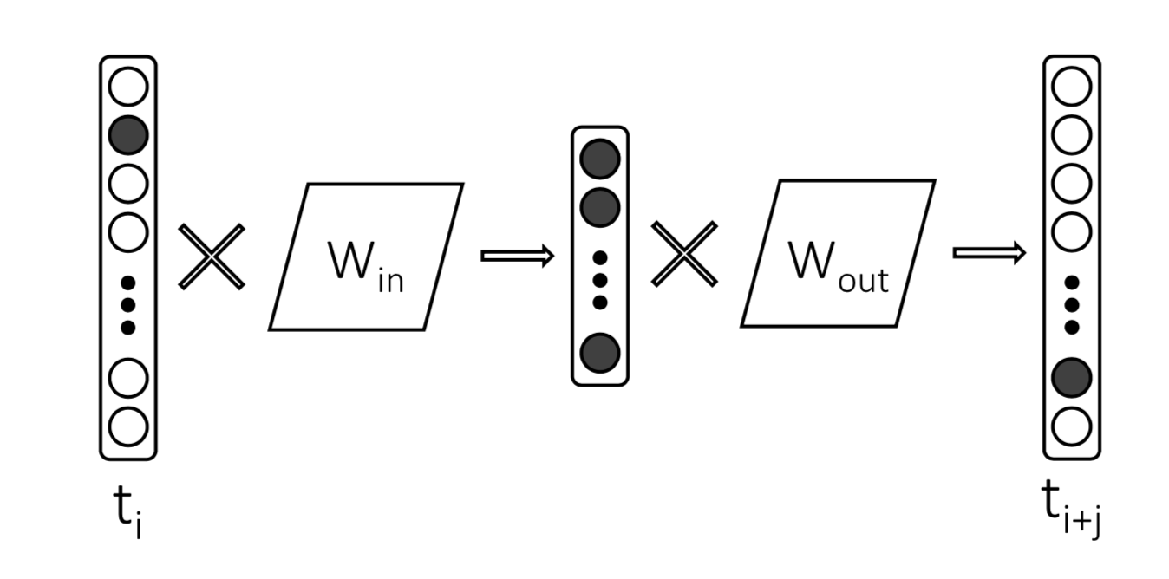

Size of Input layer (ti) = 1*5000

Size of Hidden layer = 1*300

Size of Output layer (ti+j) = 1*5000

Size of Target Matrix (Win) = 5000 * 300

Size of Context Matrix (Wout) = 300*5000

**Question 2:**

Represent the word “oranges” as vector using following corpus. Use TF.IDF weights. Assume the window size for word context is 3. [5 Marks]

Document 1: I like to ride cycle often.

Document 2: Ali and Hassan ate apple and oranges in the park.

Document 3: Ali ate apple not oranges in his house.

Document 4: Ali did not cross the street.

**Solution:**

Vector of Oranges:

Context words of oranges = ate, apple, and, in, the, park, not, his house

|  |  |  |  |  |  |  |  |  |  |  |  |  |  |  |
| --- | --- | --- | --- | --- | --- | --- | --- | --- | --- | --- | --- | --- | --- | --- |
| Dimensions | I | like | to | ride | cycle | often | Ali | and | Hassan | ate | apple | oranges | in | the |
| IF.IDF Weights | 0 | 0 | 0 | 0 | 0 | 0 | 0 | 1*2 | 0 | 1.3*1 | 1.3*1 | 0 | 1.3*1 | 1*1 |

|  |  |  |  |  |  |  |  |
| --- | --- | --- | --- | --- | --- | --- | --- |
| Dimensions | park | not | his | house | did | cross | street |
| IF.IDF Weights | 1*2 | 1*1 | 1*2 | 1*2 | 0 | 0 | 0 |

|  |  |
| --- | --- |
| **Context Words** | **IDF** |
| Ate | Log (4/2) = 1 |
| Apple | Log (4/2) = 1 |
| And | Log (4/1) = 2 |
| In | Log (4/2) = 1 |
| The | Log (4/2) = 1 |
| Park | Log (4/1) = 2 |
| Not | Log (4/2) = 1 |
| His | Log (4/1) = 2 |
| House | Log (4/1) = 2 |